**47. Framework Design Plan**

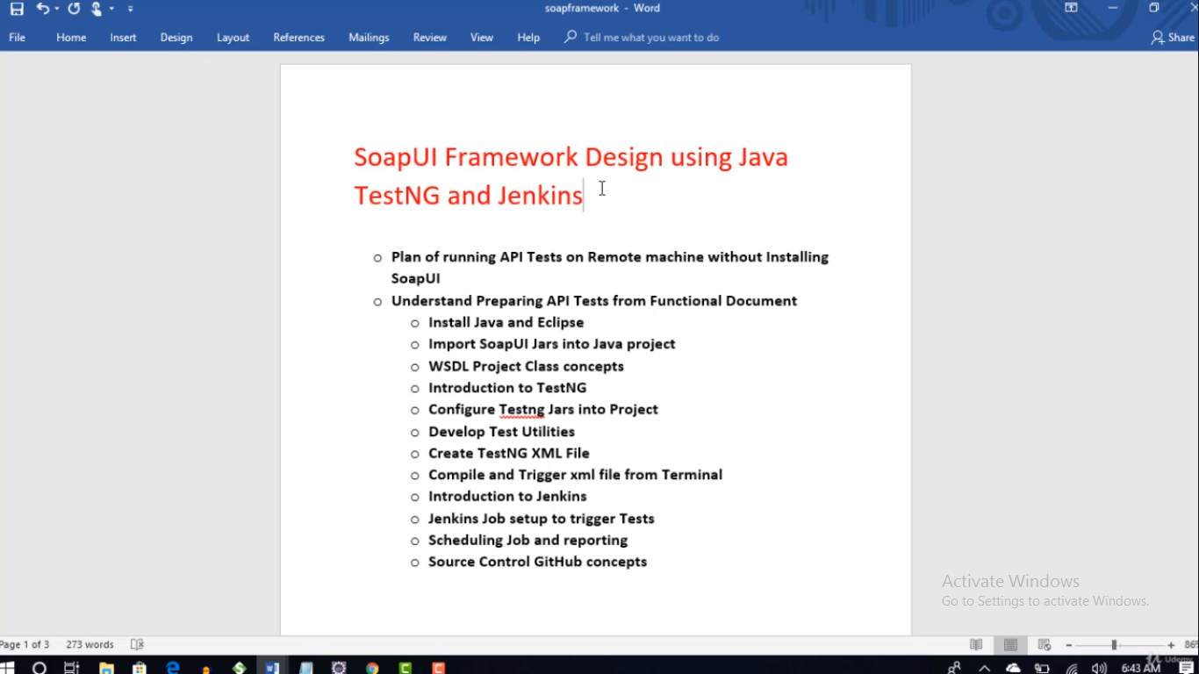

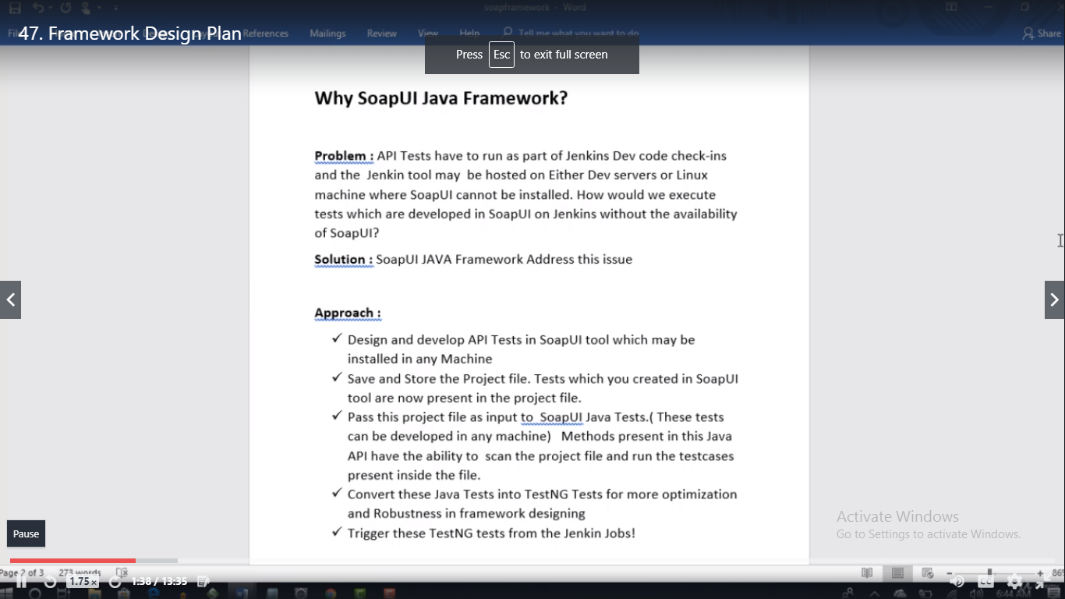

**48. Understand Preparing API Tests from the functional Documents**

* In case of rest we wont get WSDL file. Only in case of Soap.

**50. Building Rest API project in SoapUI**



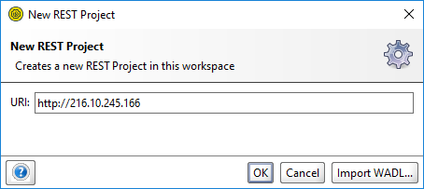

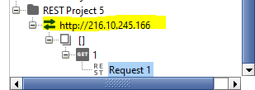

* Delete this:

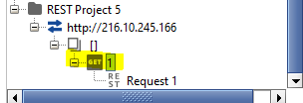

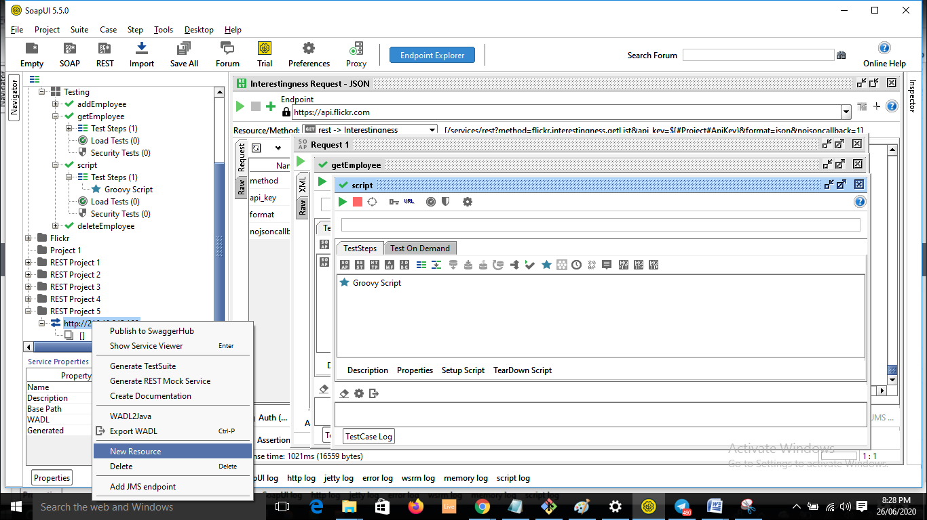 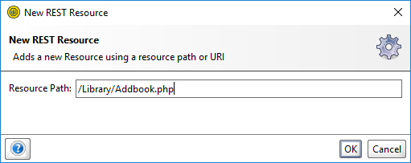

* No

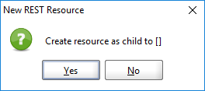 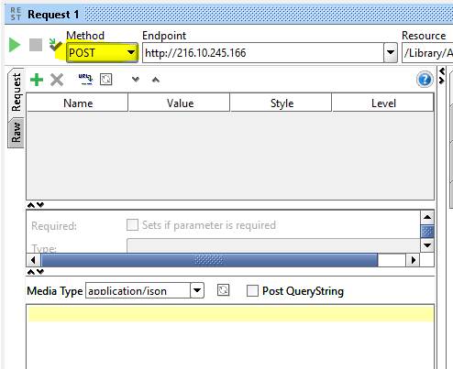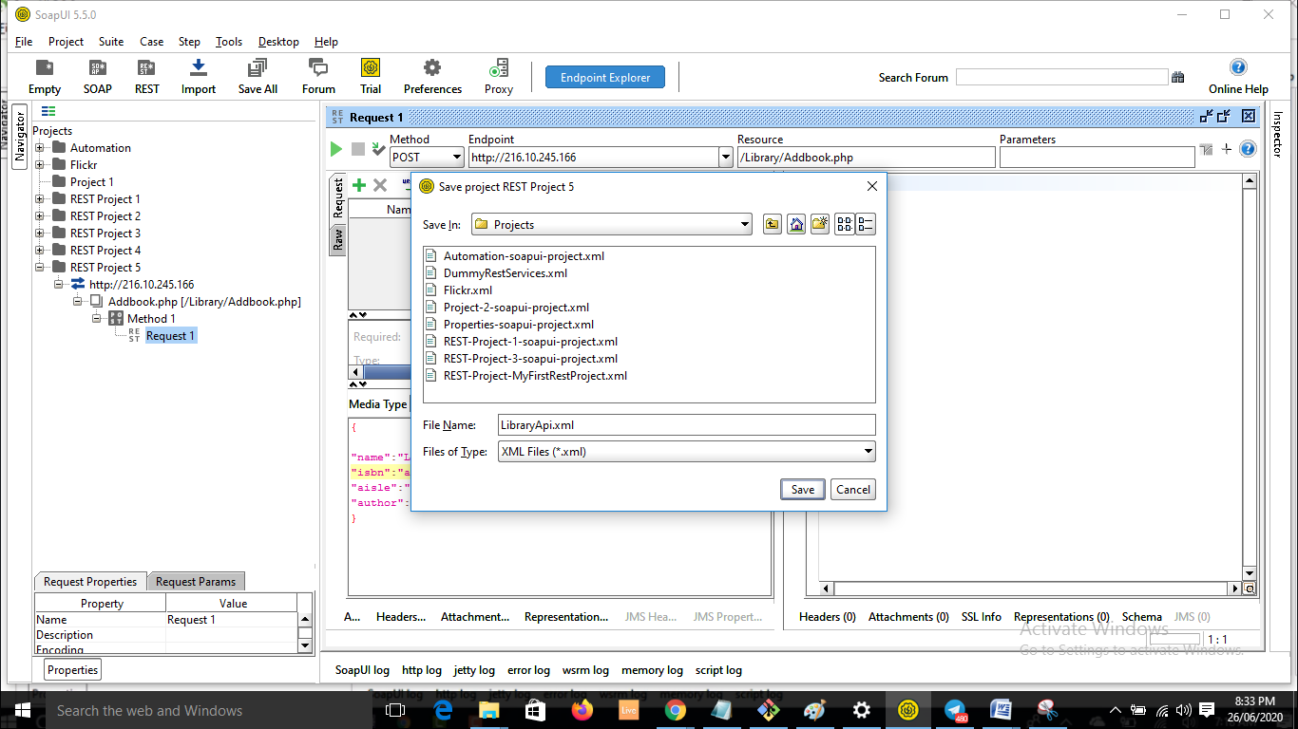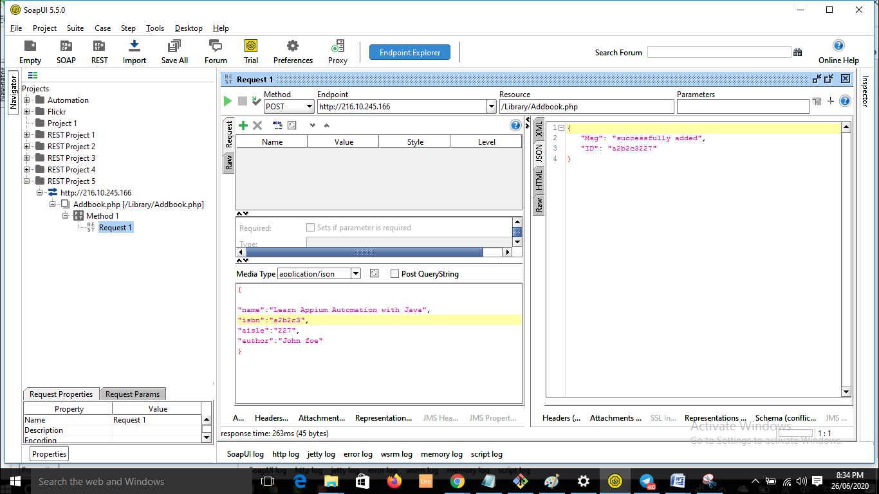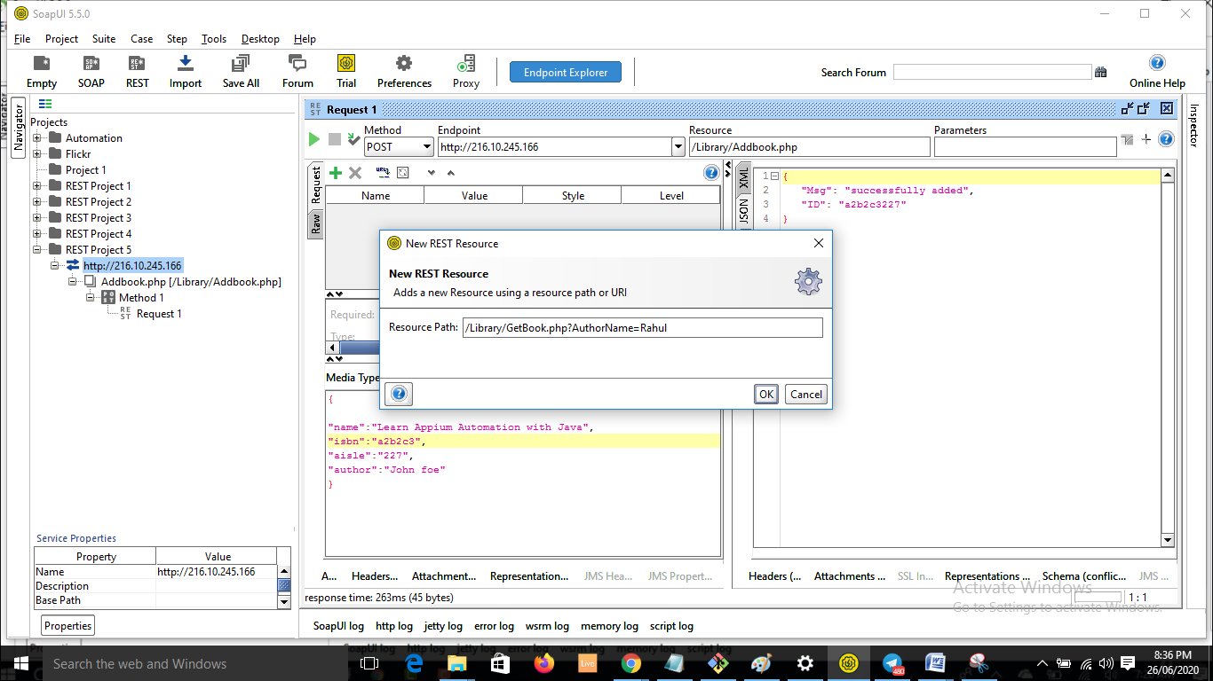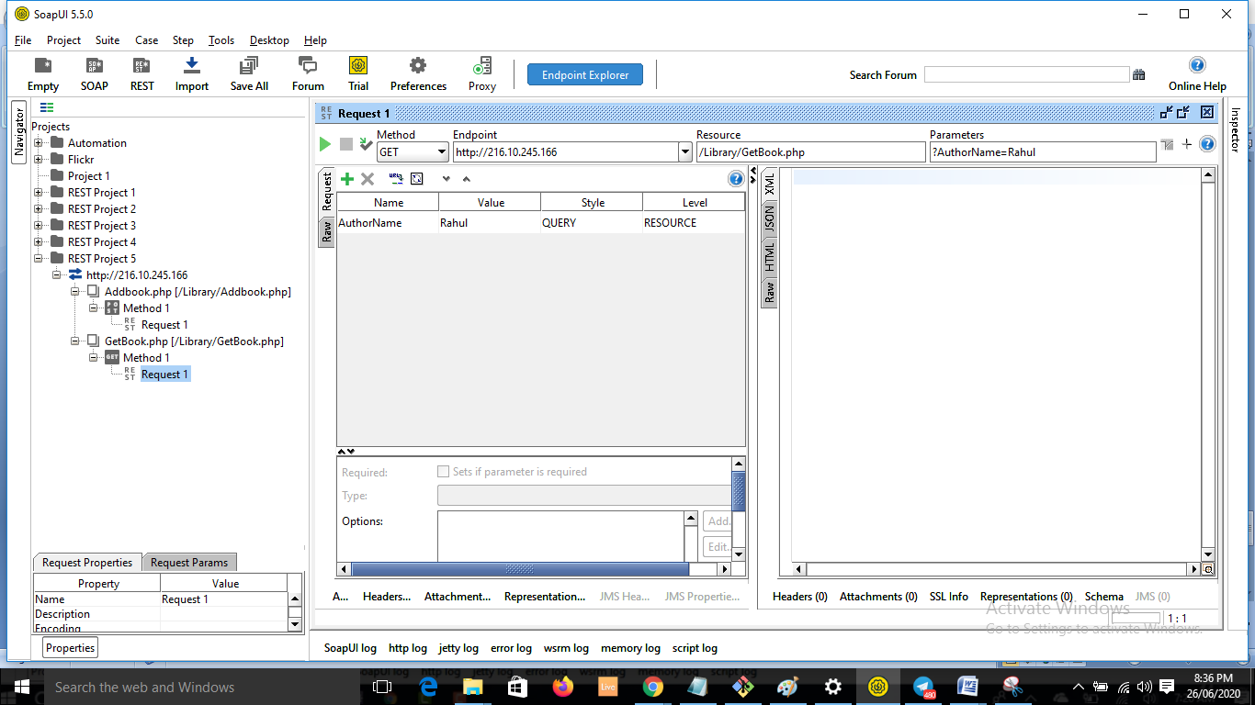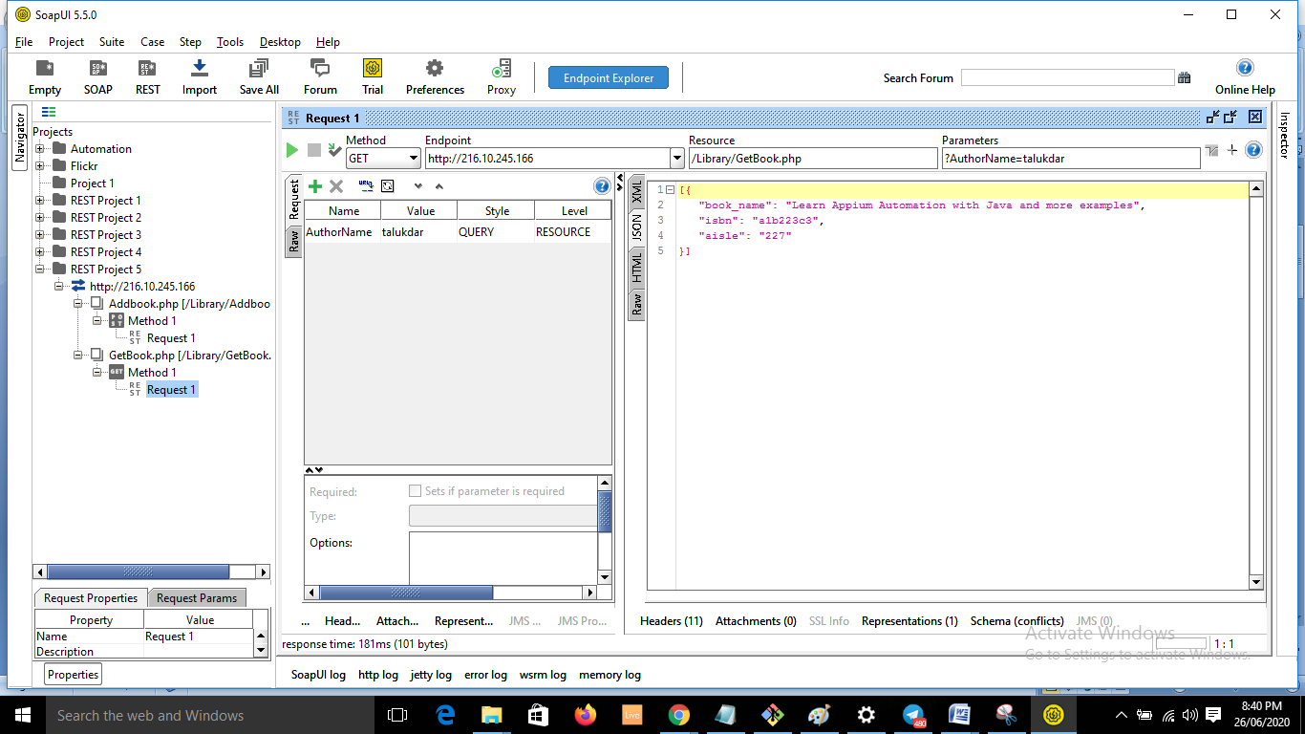

* **Resource** :Library/GetBook.php?ID=3389      - **Method** : GET

**Output Json :**

{

"book_name": "Selenium automation using Java",

"isbn": "a23hd738",

"aisle": "1223"

}

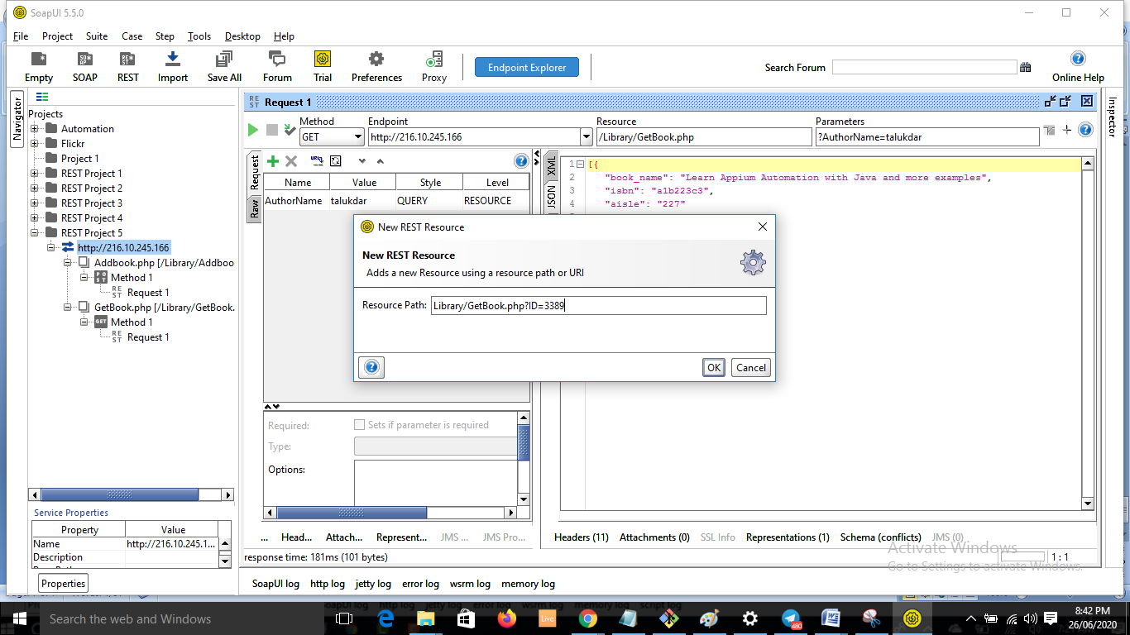

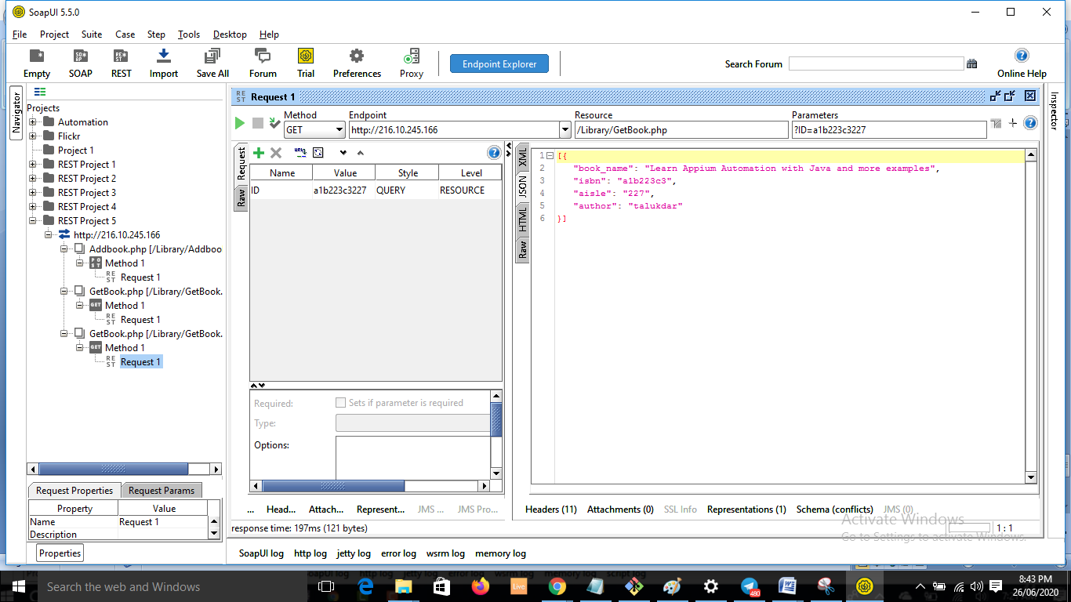

* **Resource** :/Library/DeleteBook.php      **Method** : POST

**Input Payload : Json:**

{

"ID" : "a23h345122332"

}

**Output Response** :

{  
  
msg : book is successfully deleted”

}

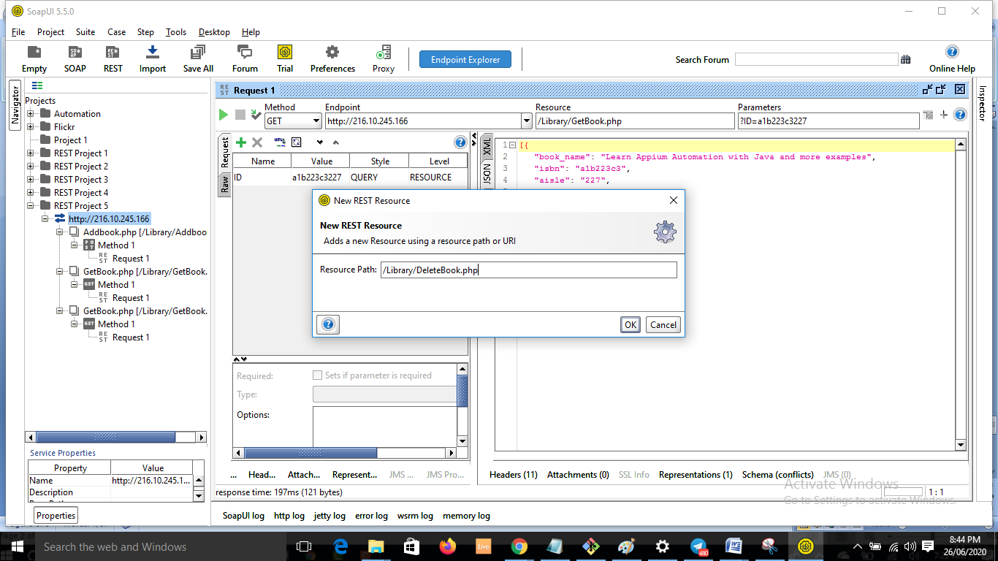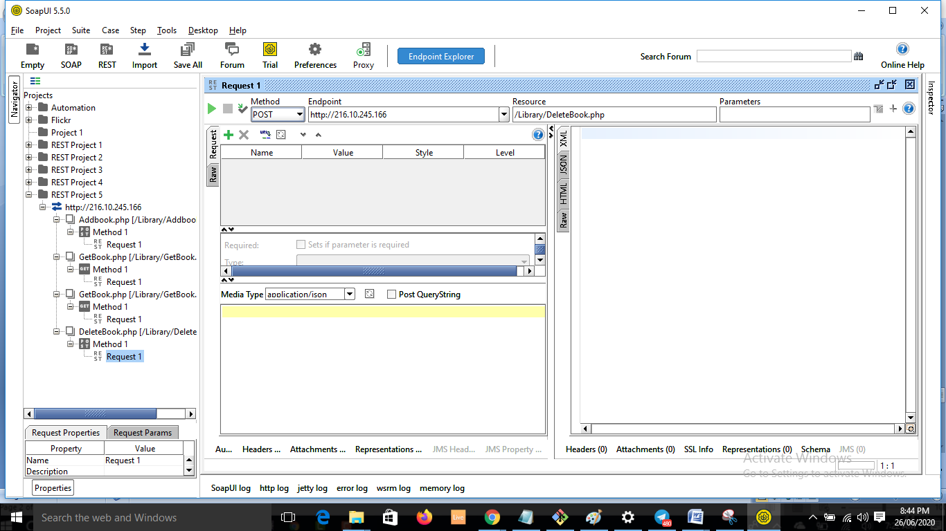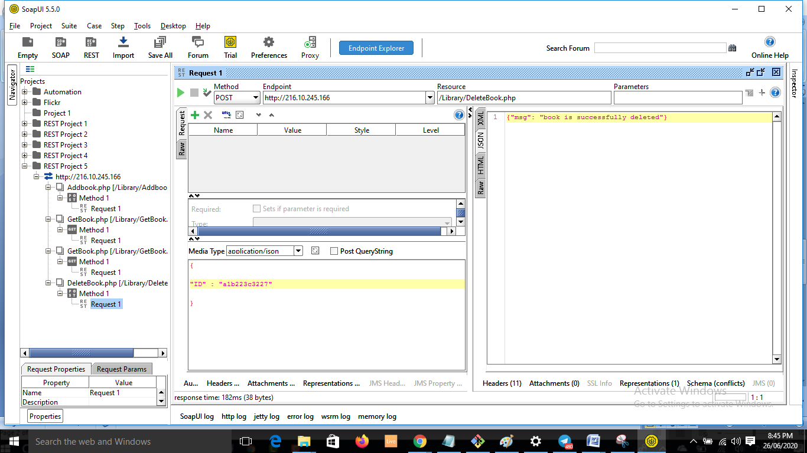

**51. create Testcases from the defined API**

* Lets create test suite now.

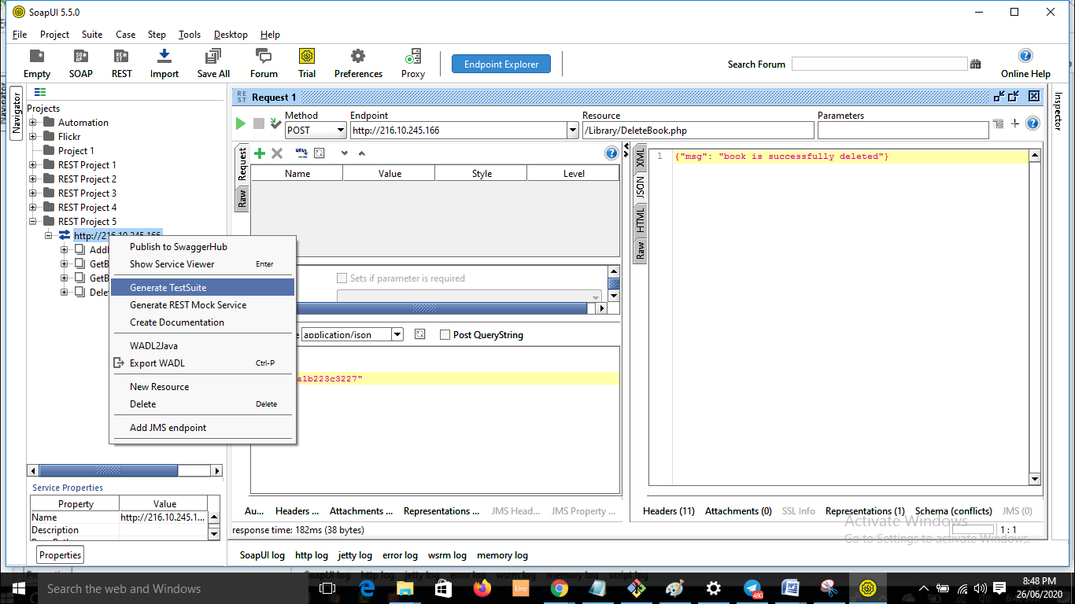

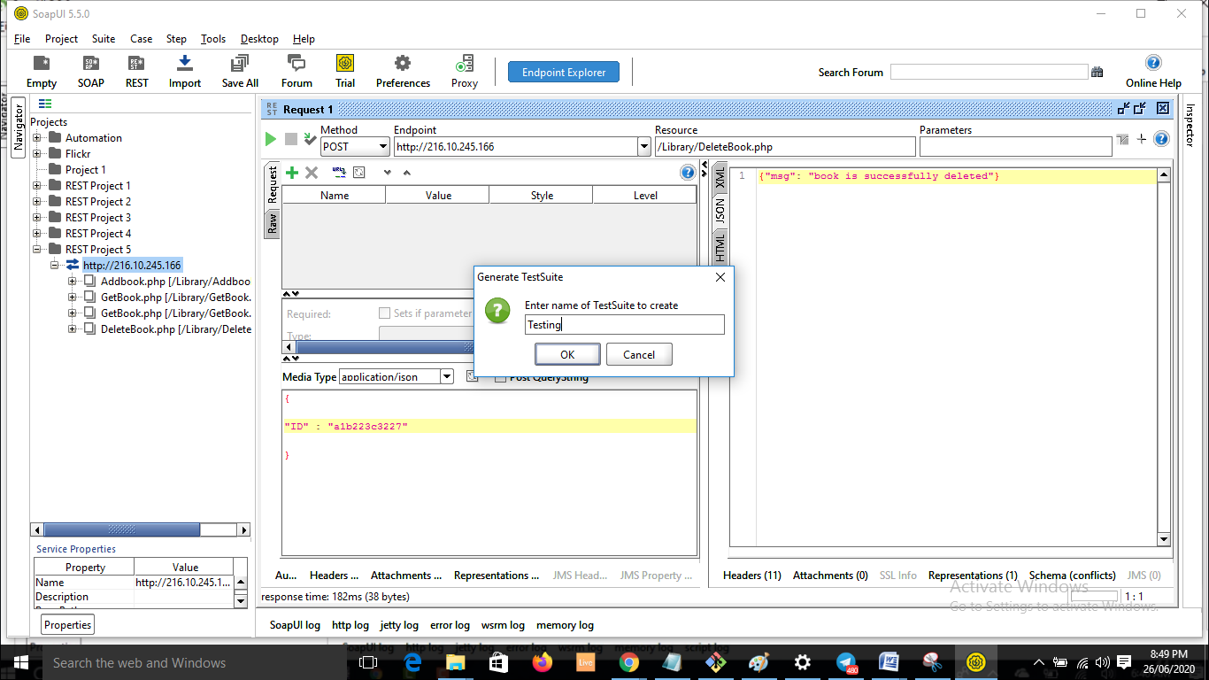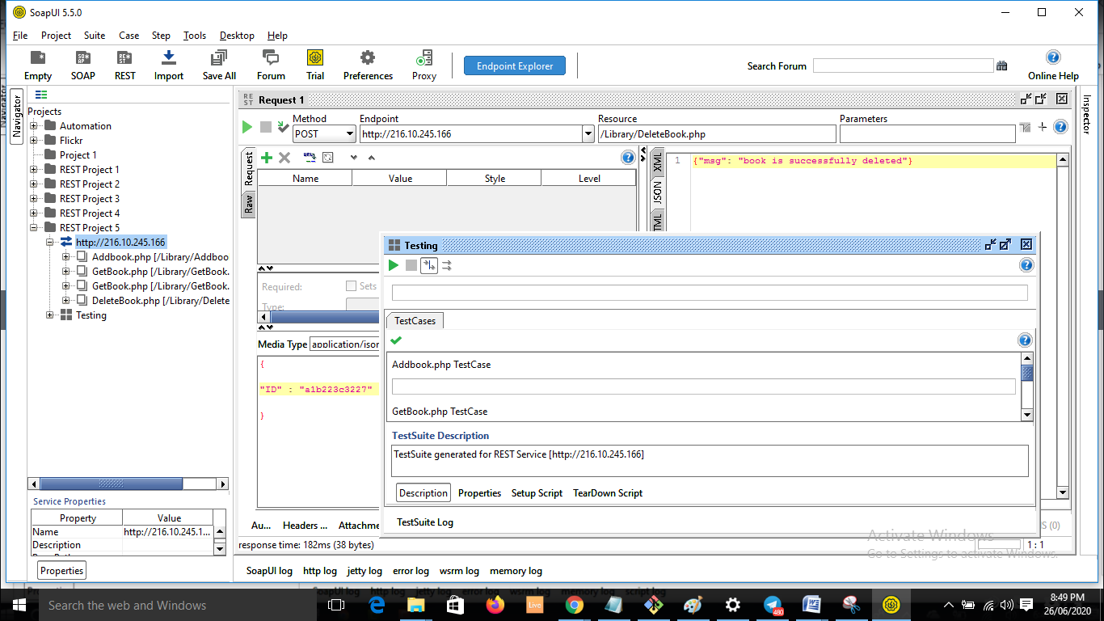

* We don’t give like this:

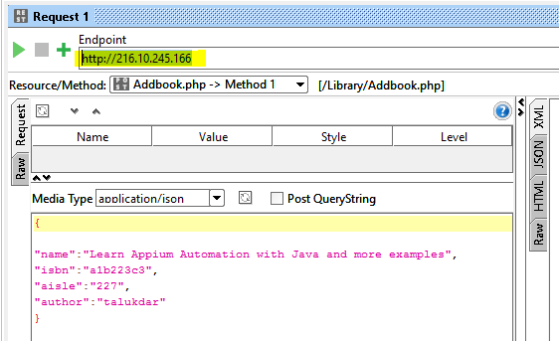

* Provide the uri or endpoint in custom Properties

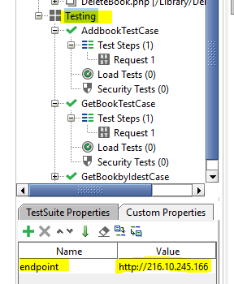

* Author

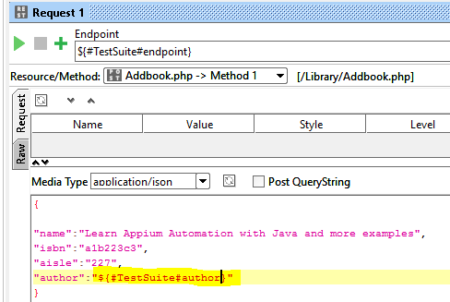 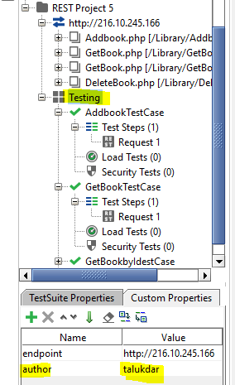

* Add assertion

successfully added

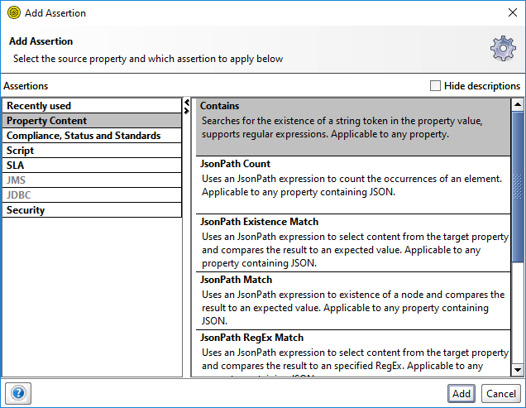 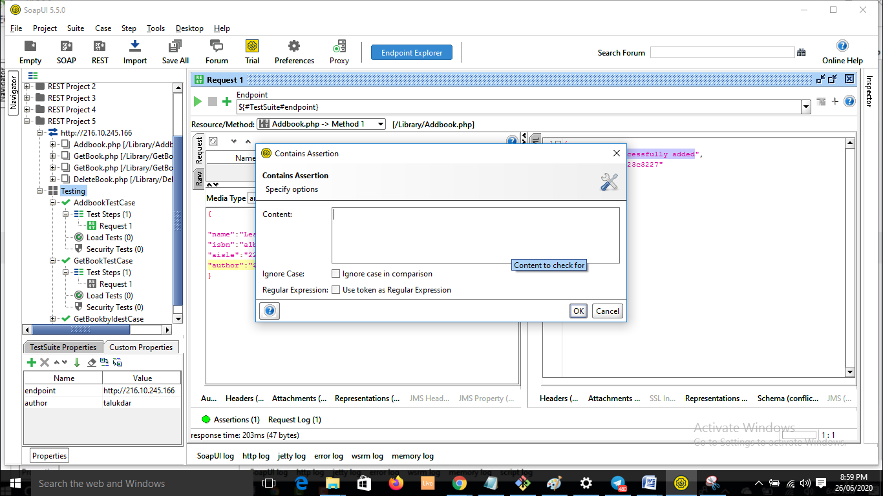 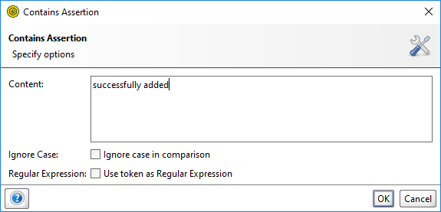 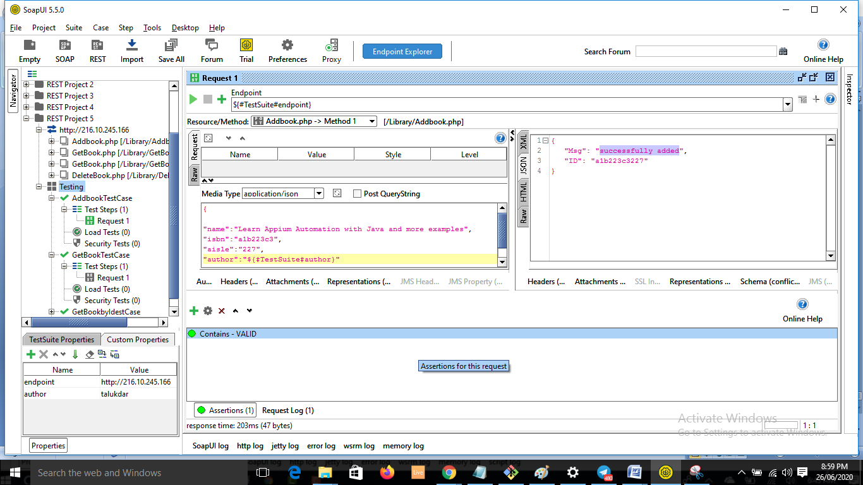

* GetBookByAuthorTestCase

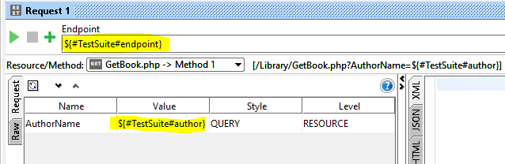

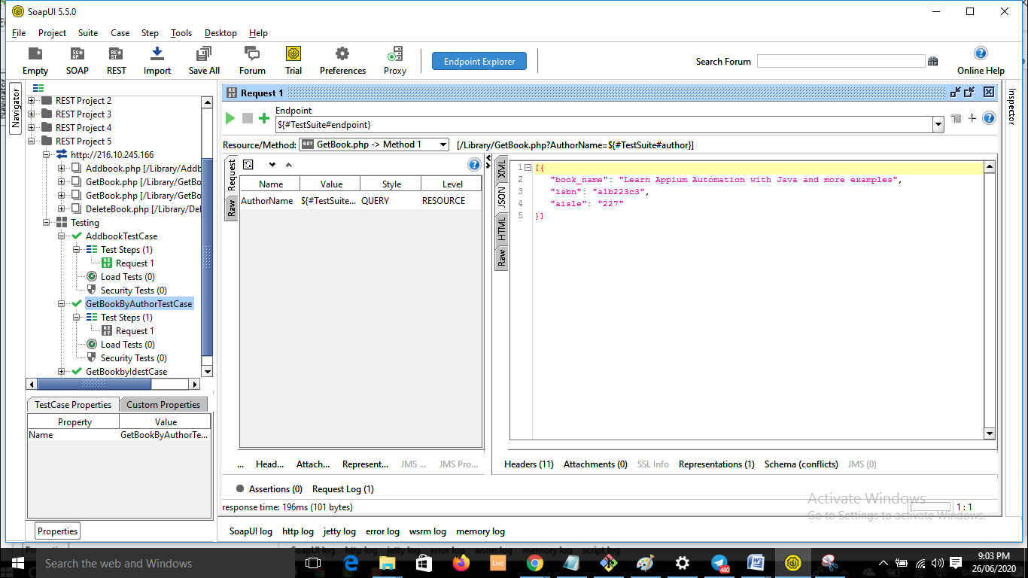

* We have to check whether the book we added in the first request is displaying or not. Lets write a simple rest assertion.

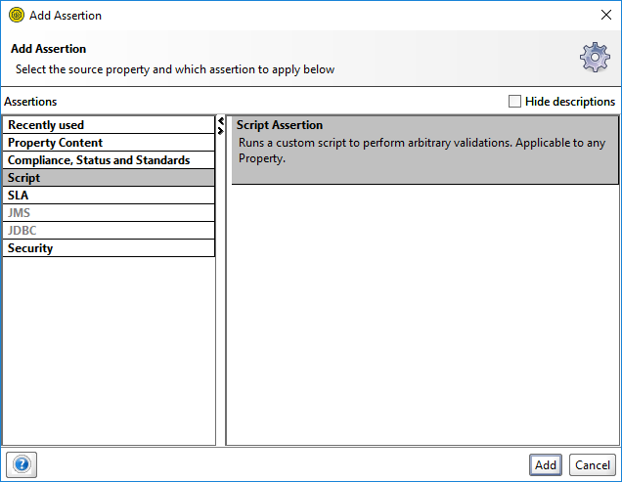

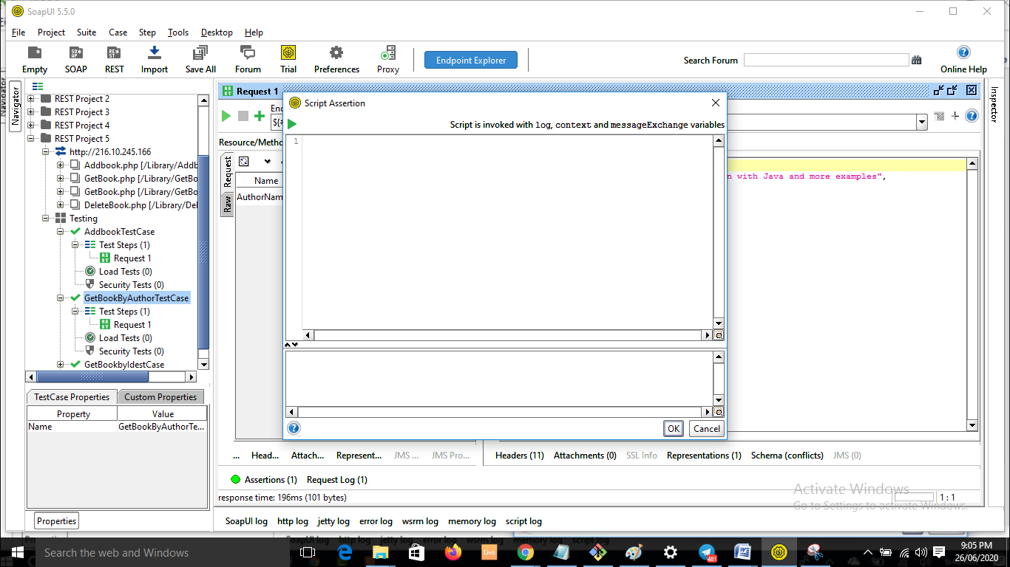

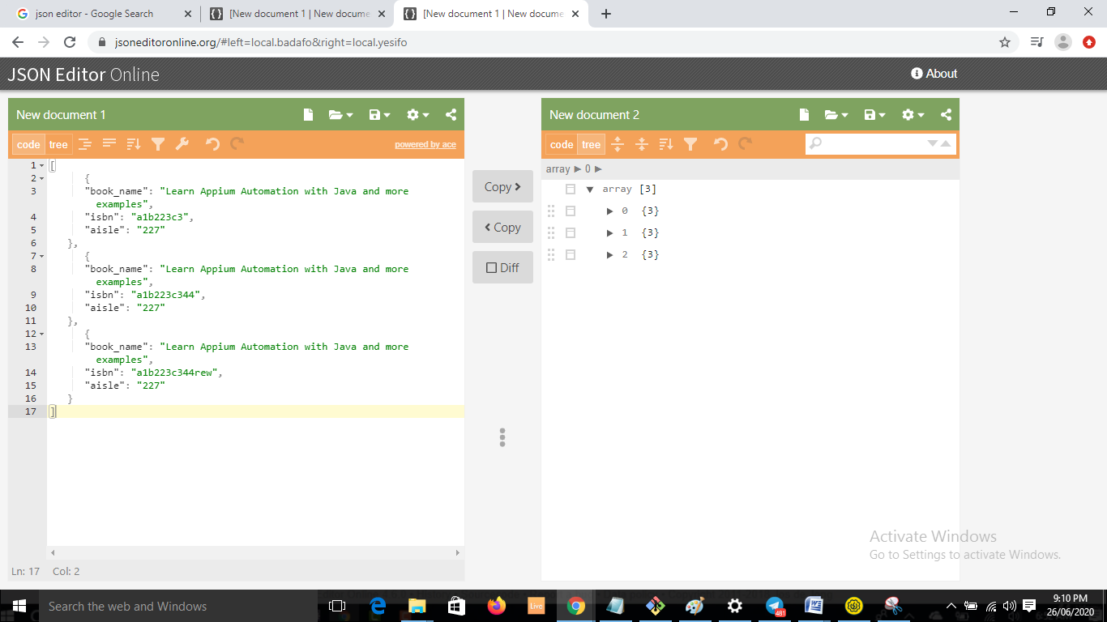

* Search a book with a particular isbn.

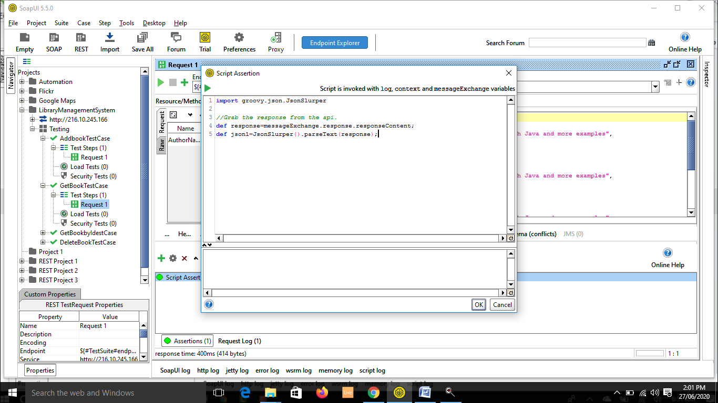

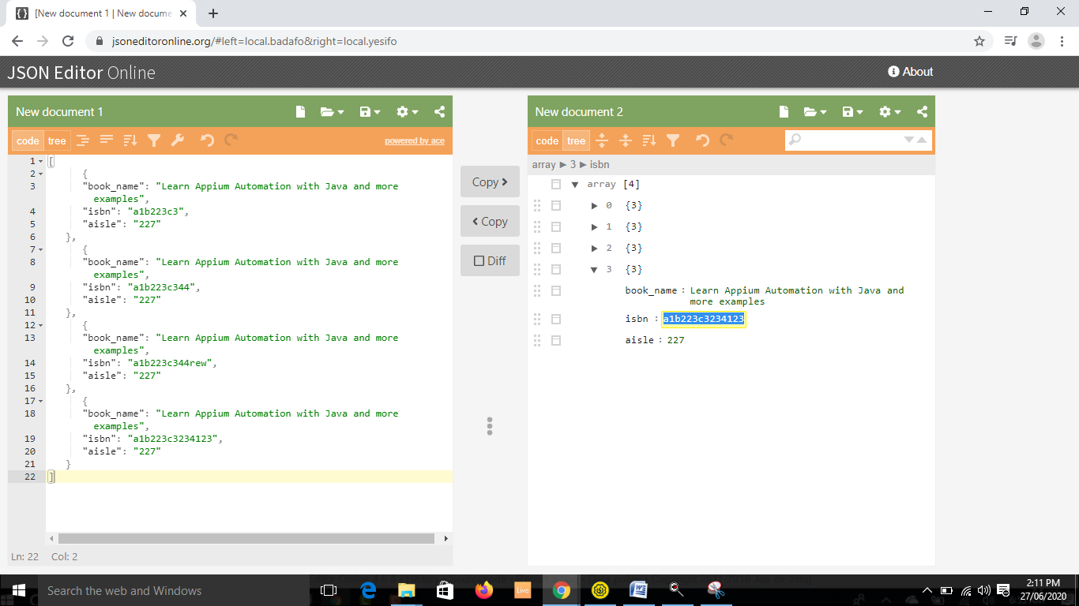

**52. End to End Testing on Library API**

import groovy.json.JsonSlurper

boolean flag;

//Grab the response from the api.

def response=messageExchange.response.responseContent;

def json1=new JsonSlurper().parseText(response);

for(i=0;i<4;i++){

if(json1.isbn[i]=="a1b223c3234123")

{

flag=true;

}

}

assert true==flag

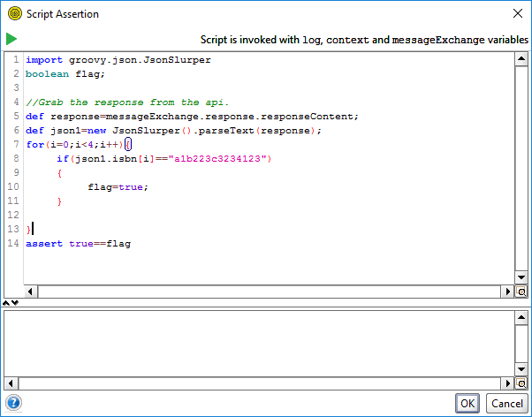

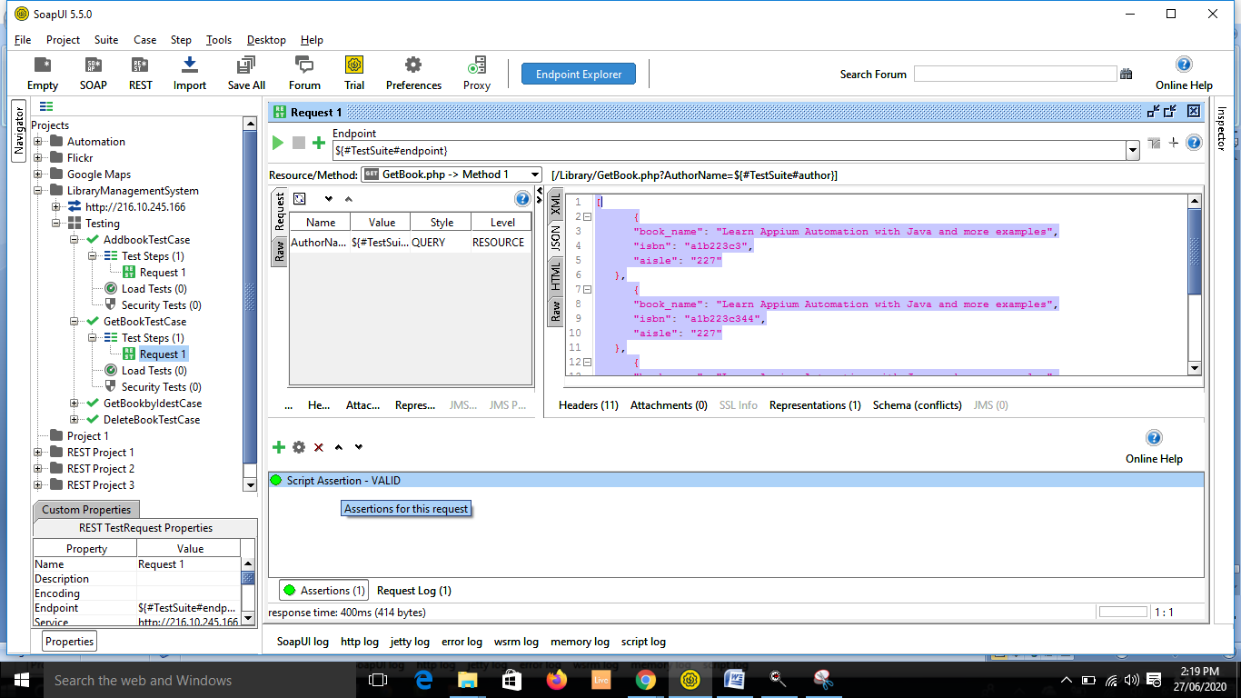

* Now delete the added book. Do it using PropertyTransfer concept.

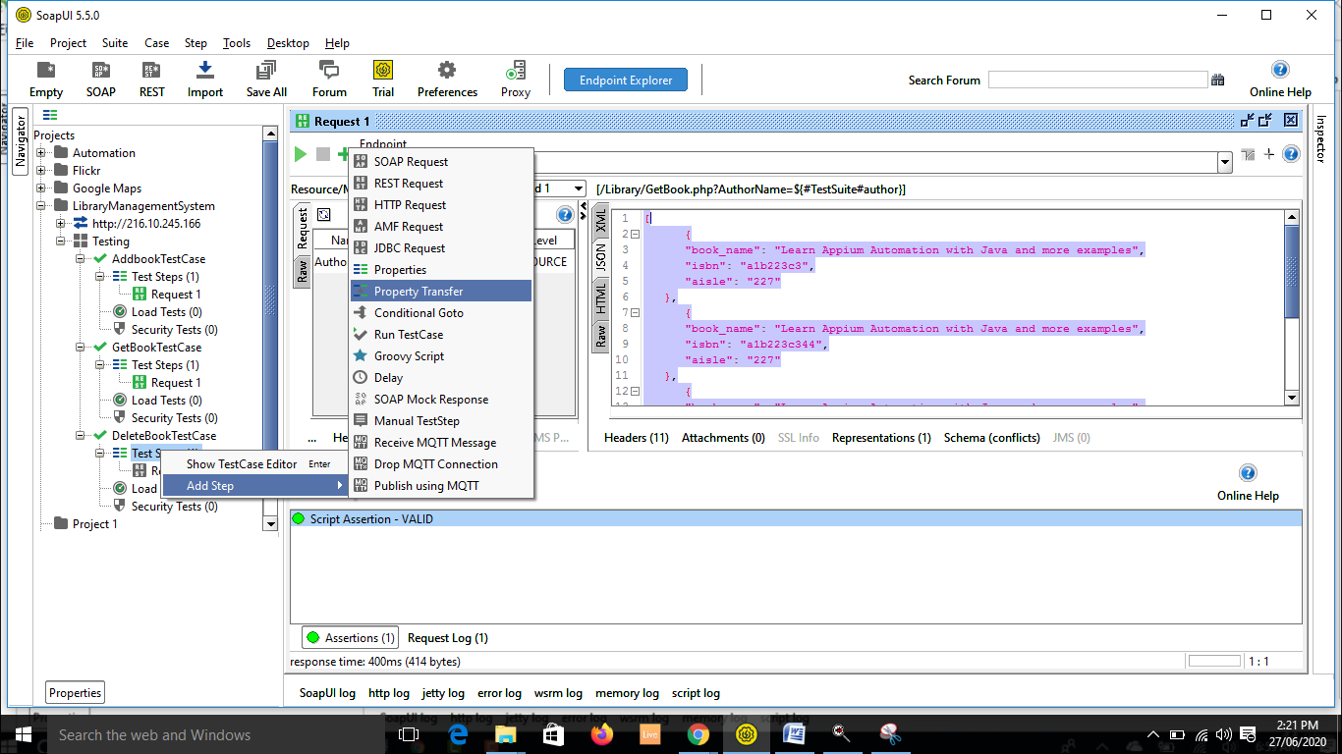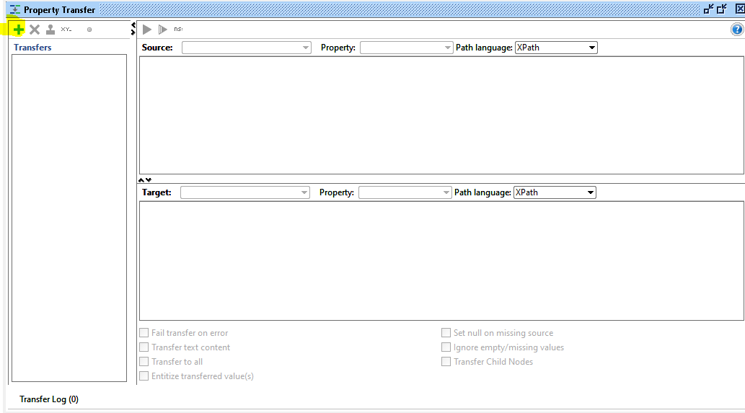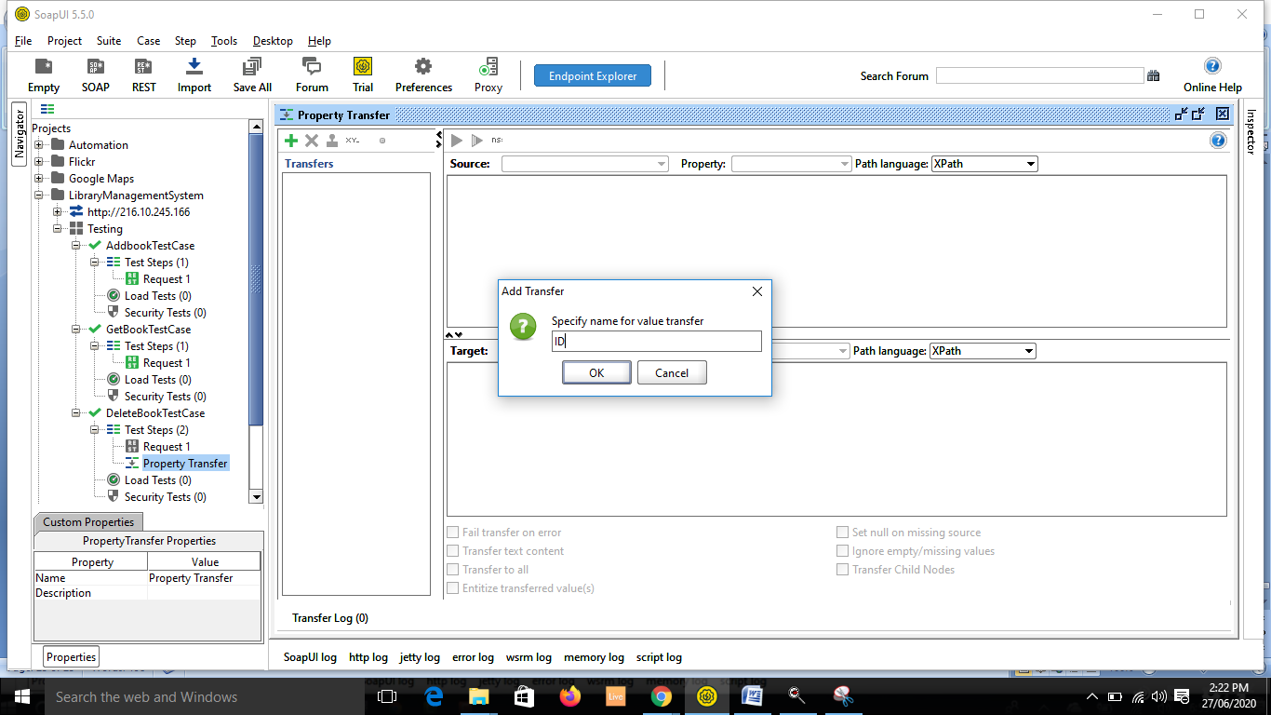

* Wait, do it with the first test case.

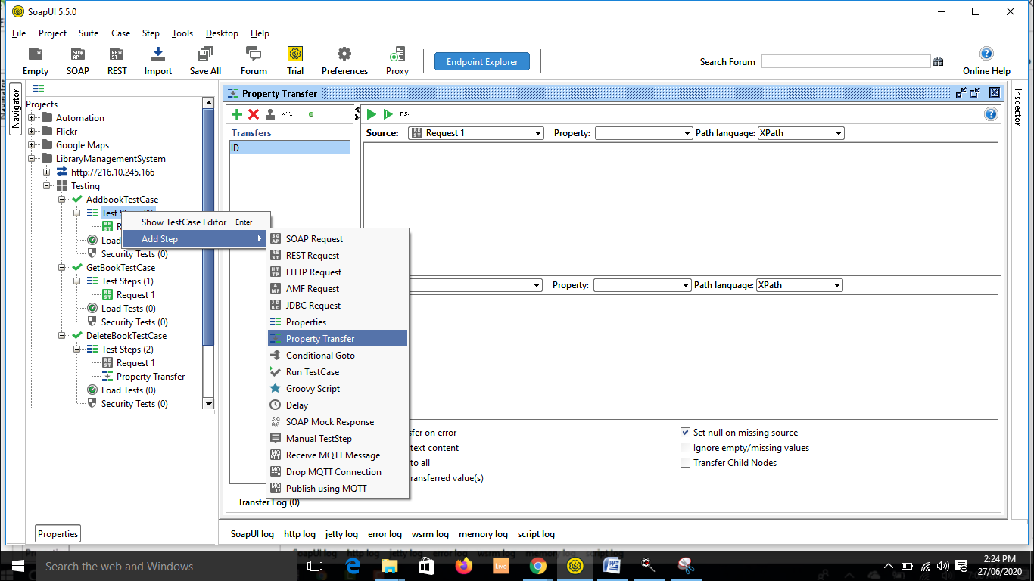

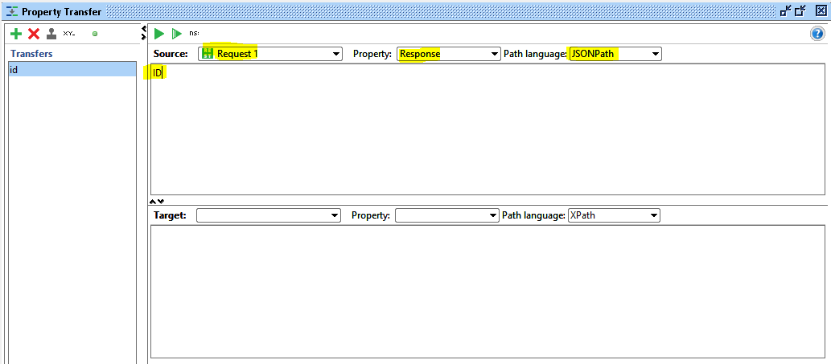

* Now place this in test suite level.

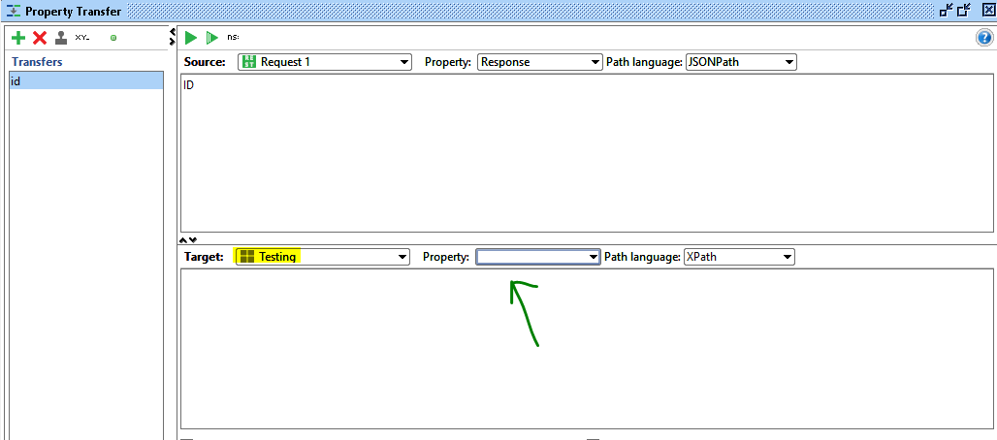

* Create a new property in TestSuite level.

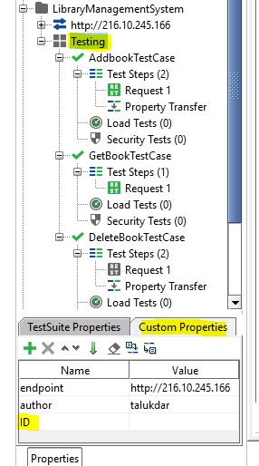

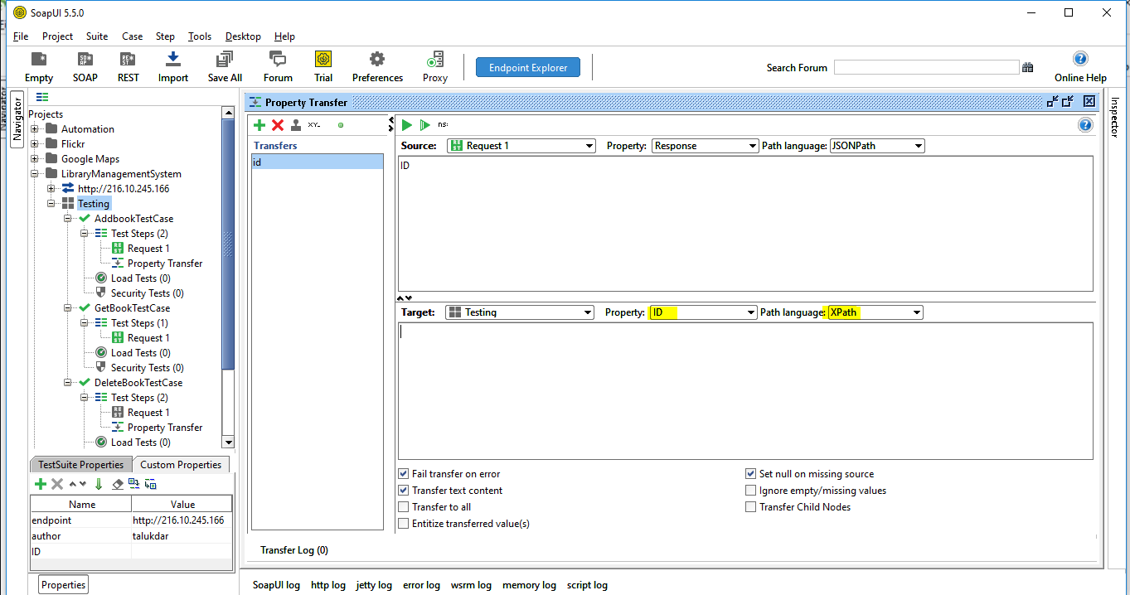

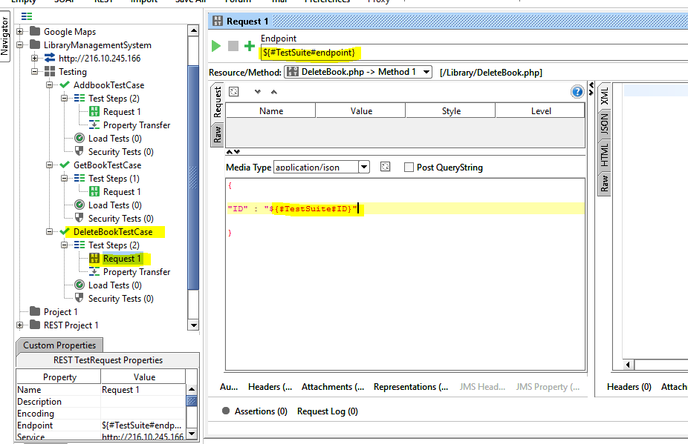

* Now run the testsuite

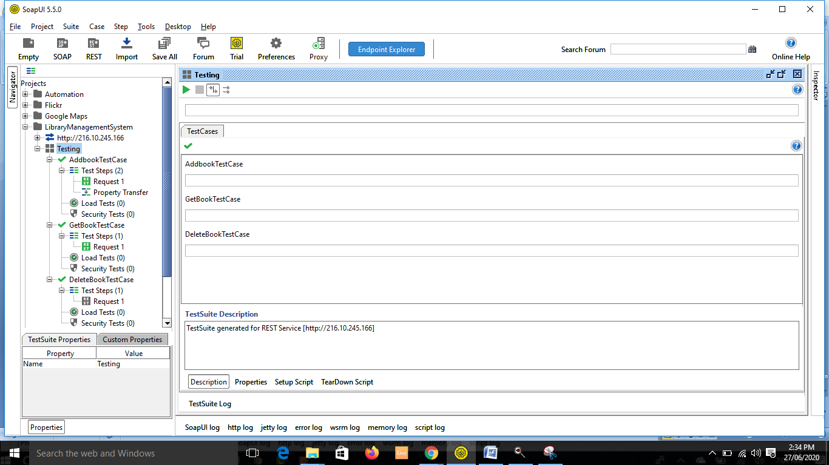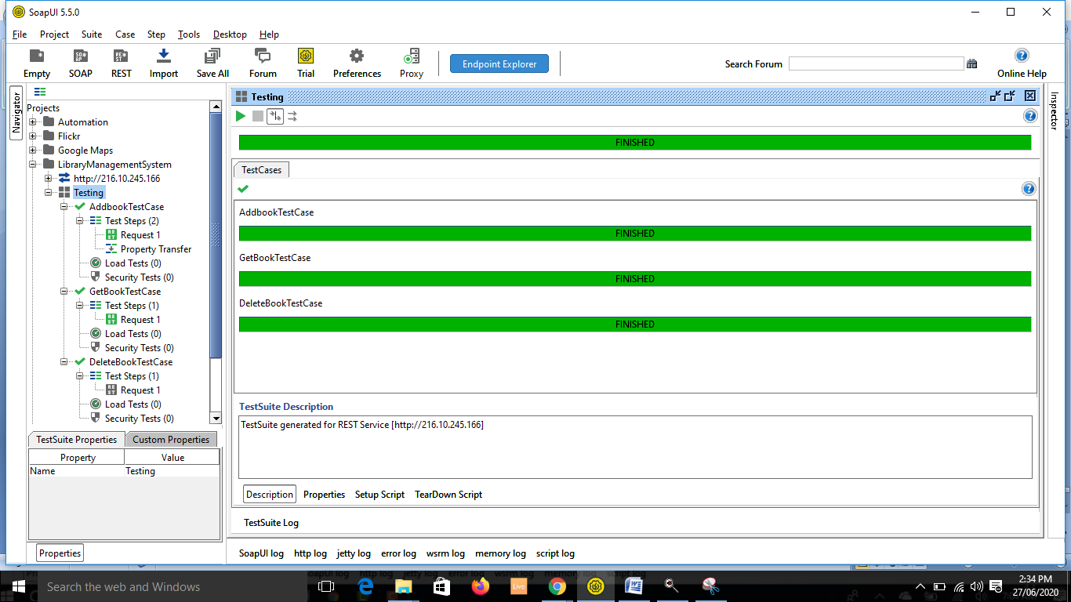

**54. Install Eclipse and Java for API Automation testing**

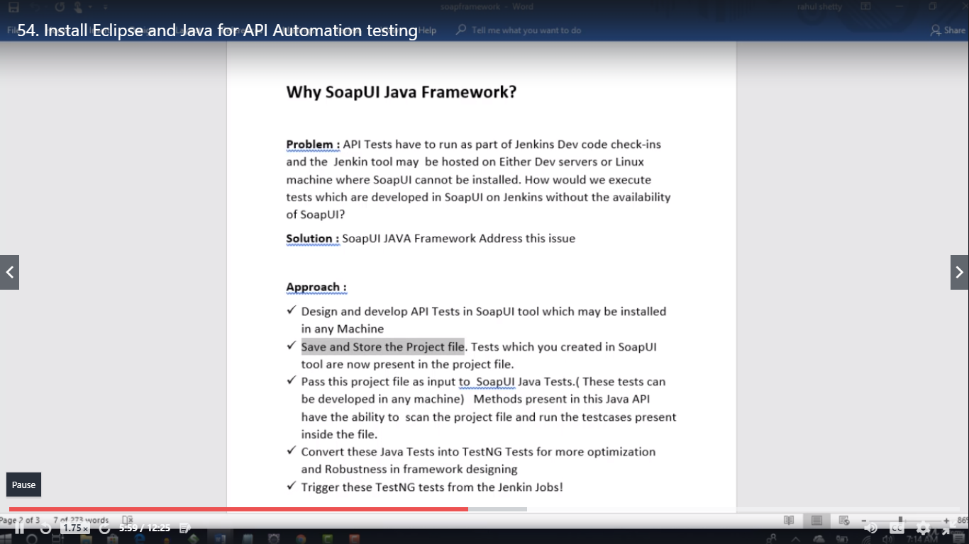

* JDK/Java installation:

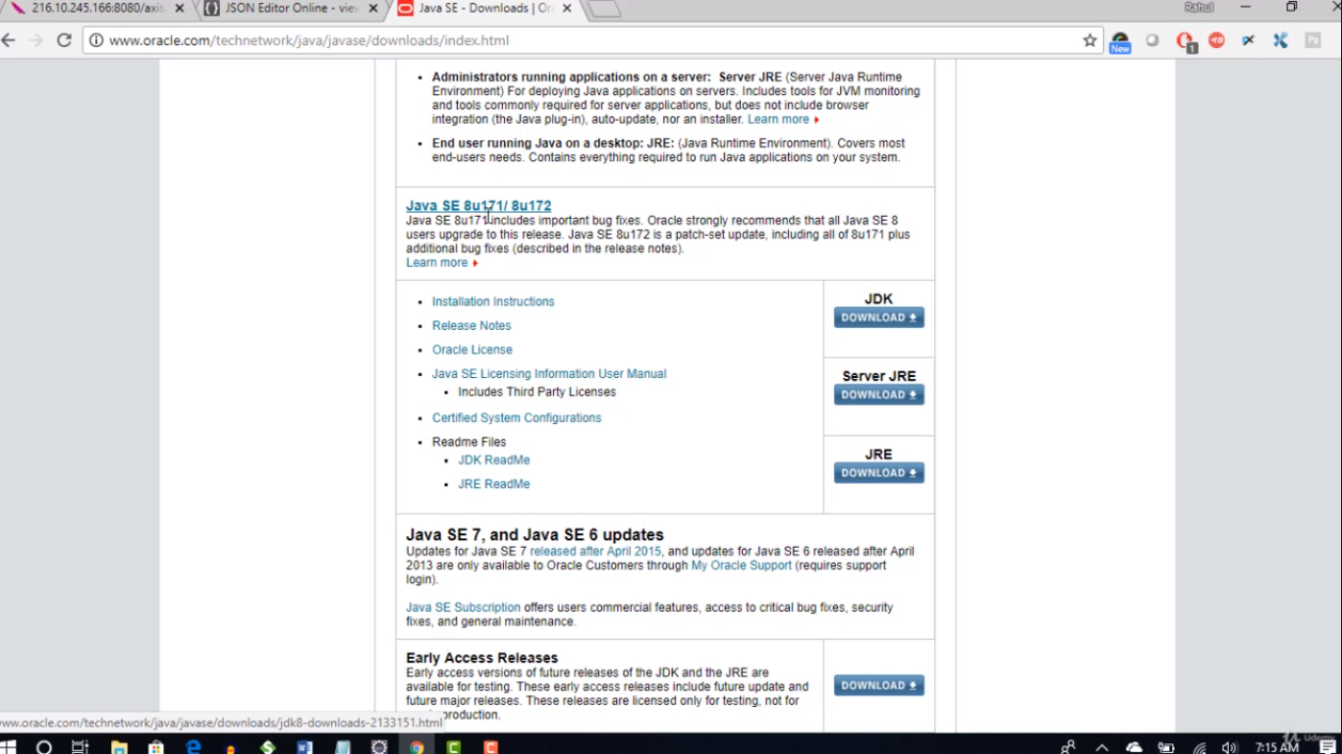

* Check in Program files:

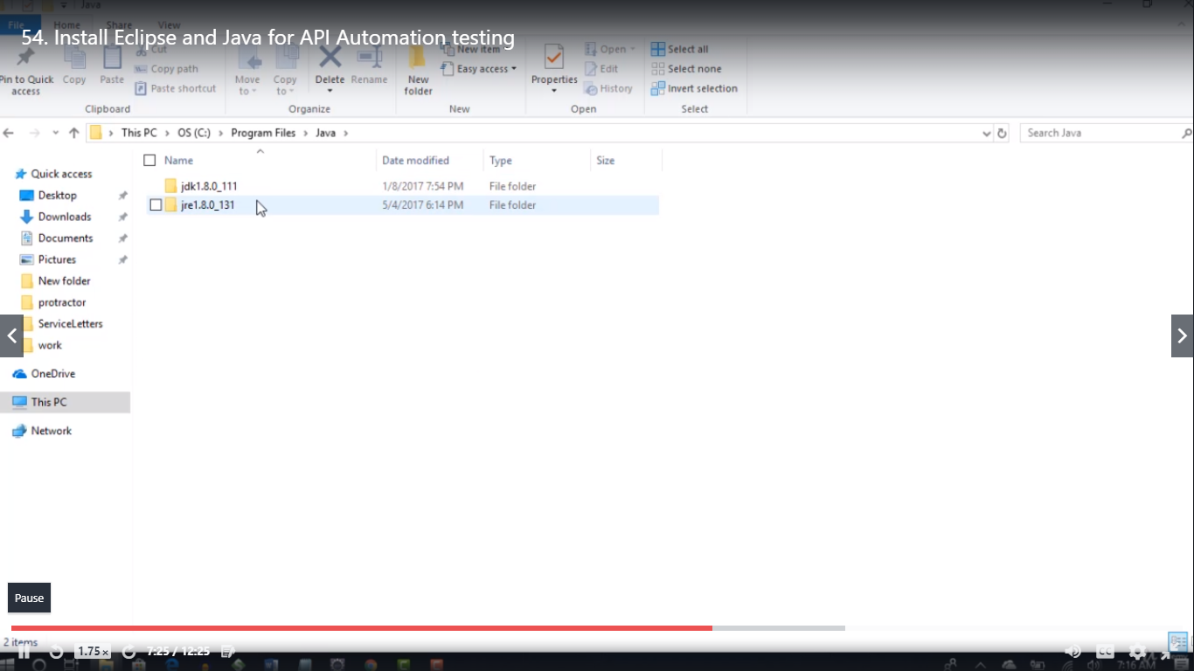

* Go and copy the path of JDK home. 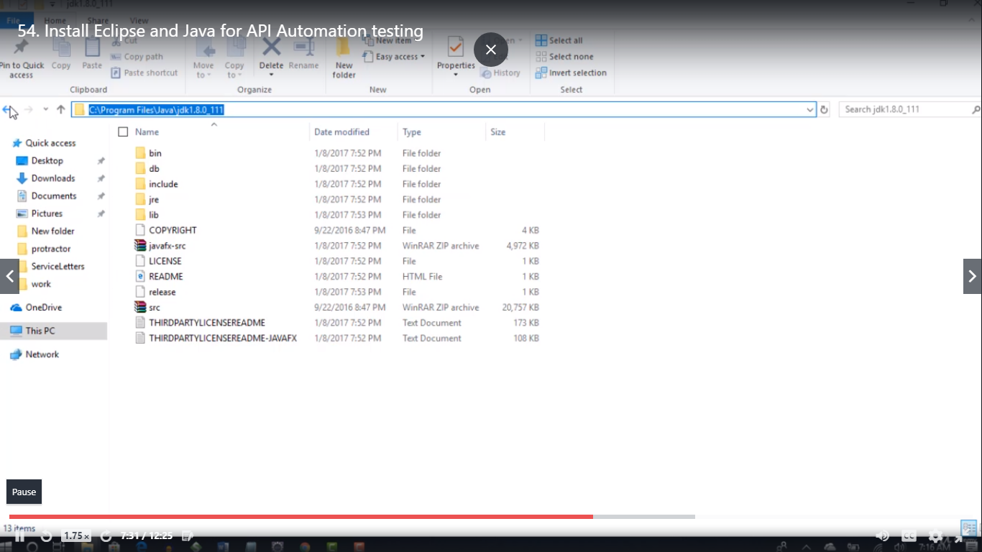

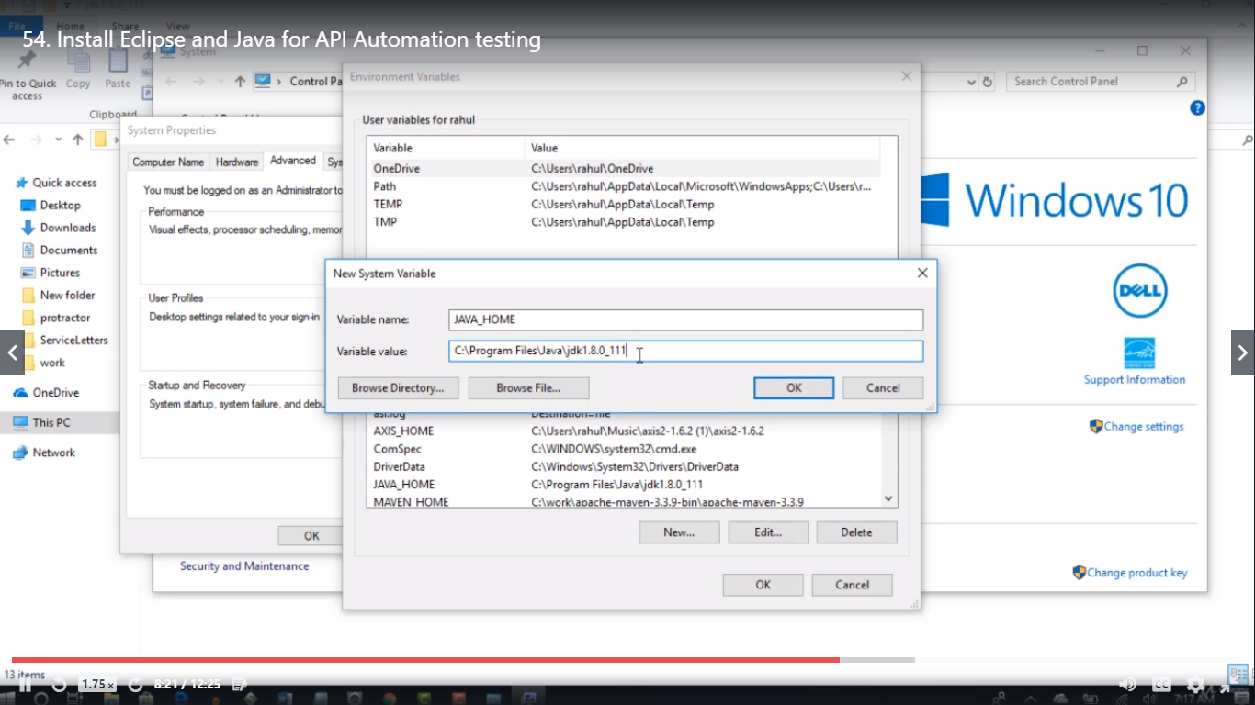

* Copy bin path

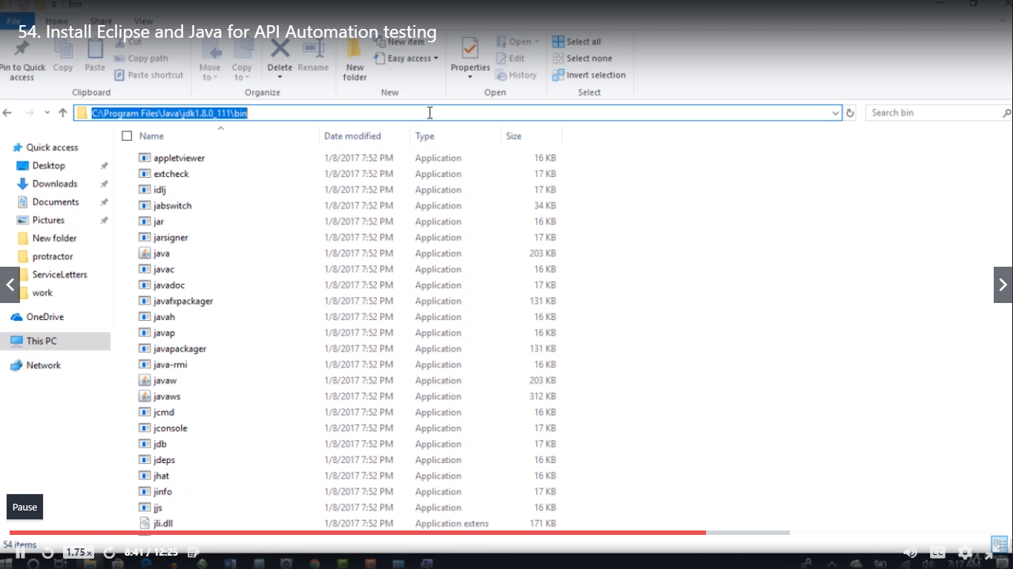

* And paste in path.

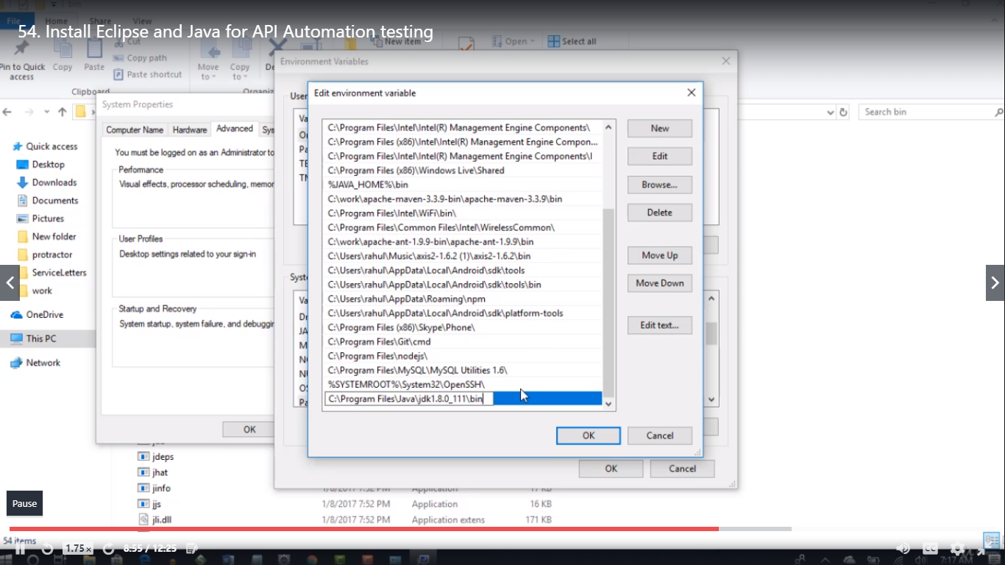

* To check java is installed.

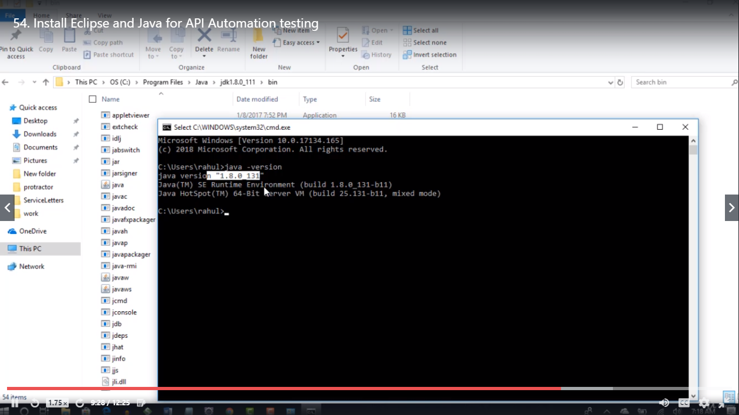

* Download Eclipse

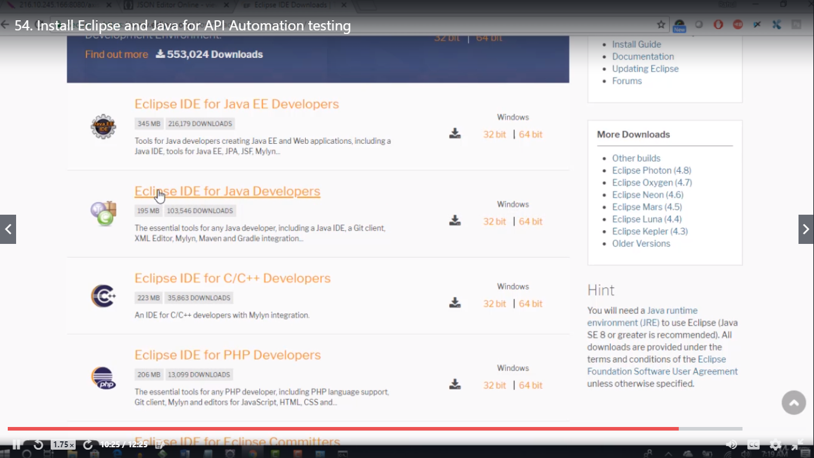

**55. Creation of Java API project for Framework setup**

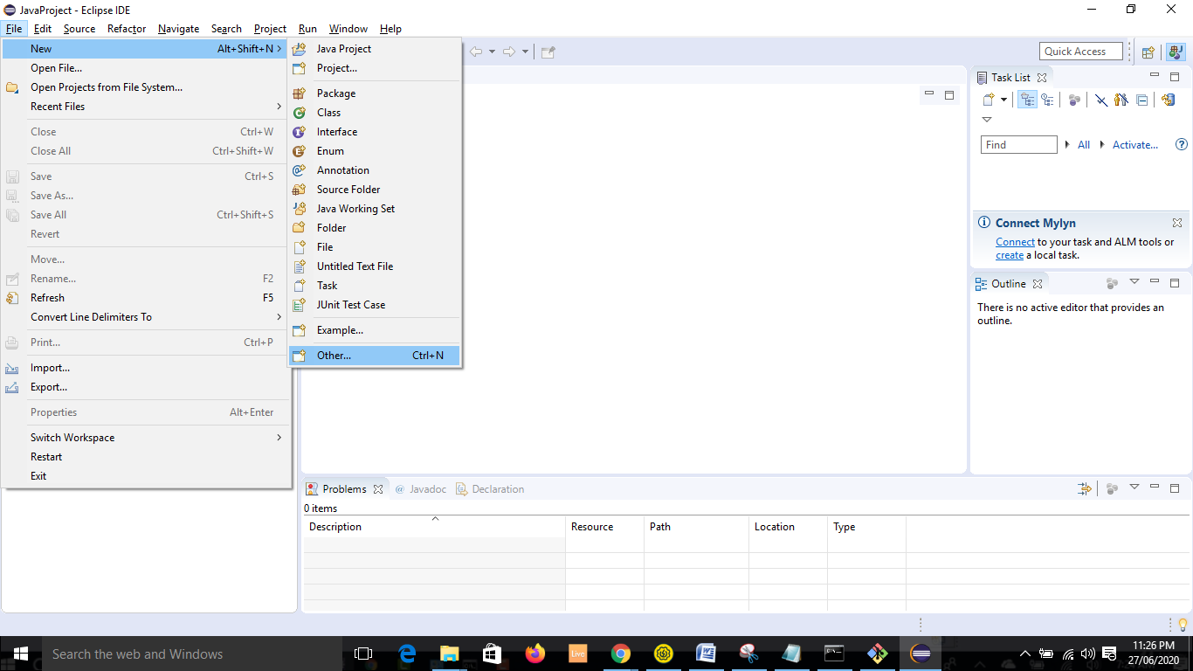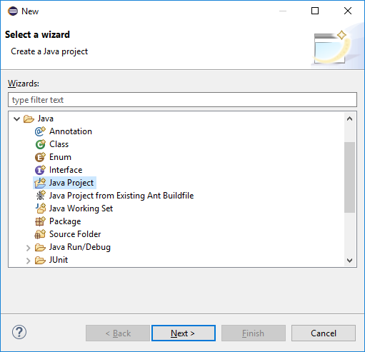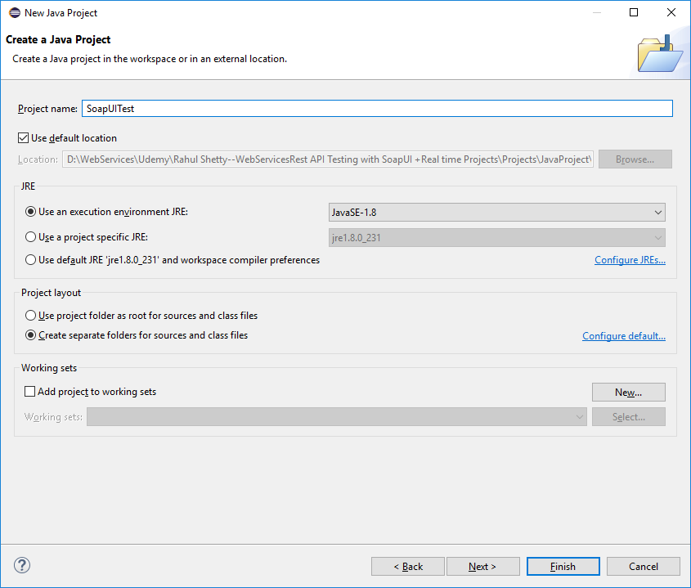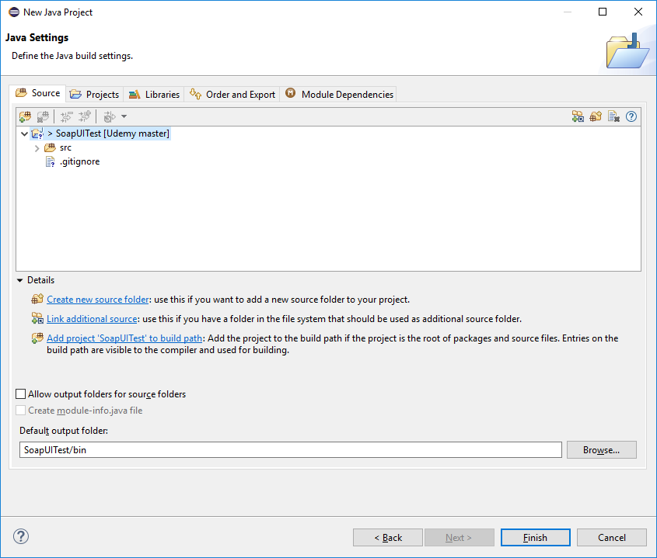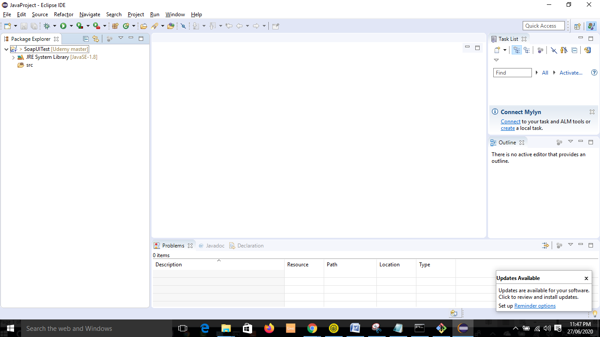

* Go to this path

C:\Program Files\SmartBear\SoapUI-5.5.0\lib

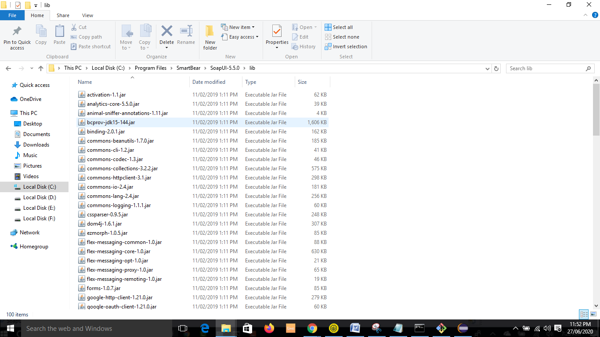

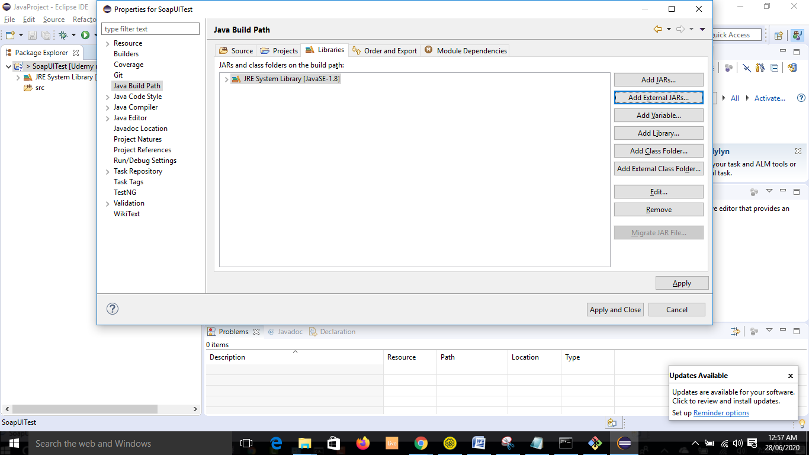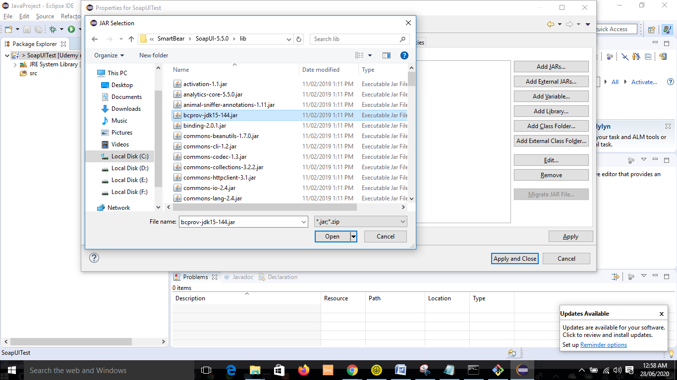

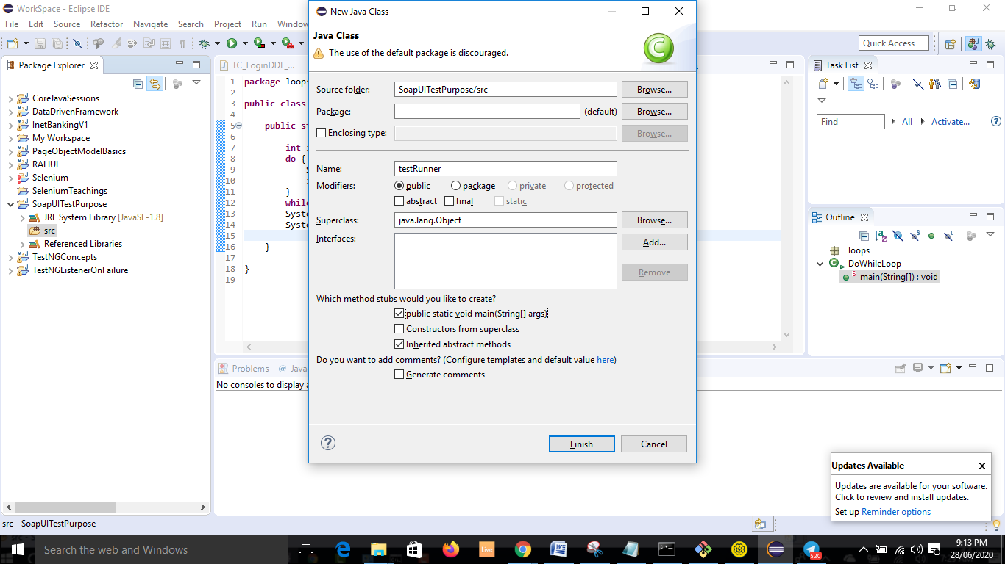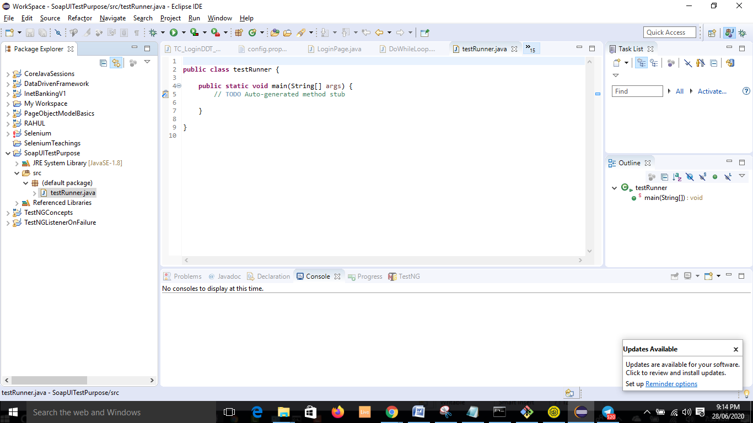

**56. WSDL Project concepts for Java tests set up**

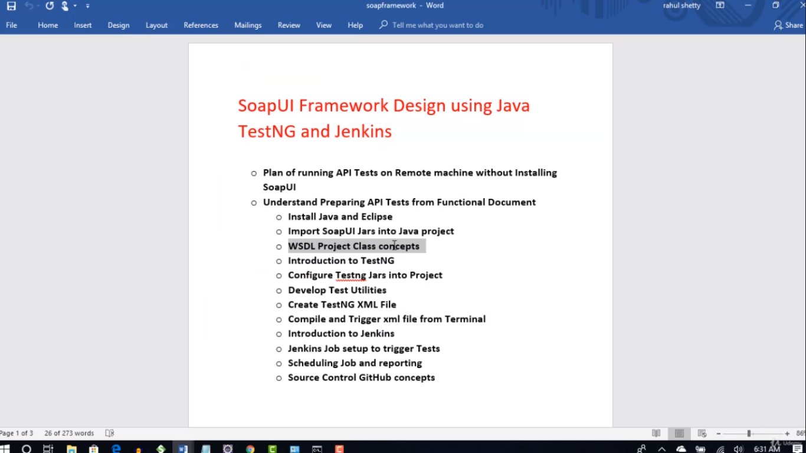

* Import one more jar: (location: C:\Program Files\SmartBear\SoapUI-5.5.0\bin)

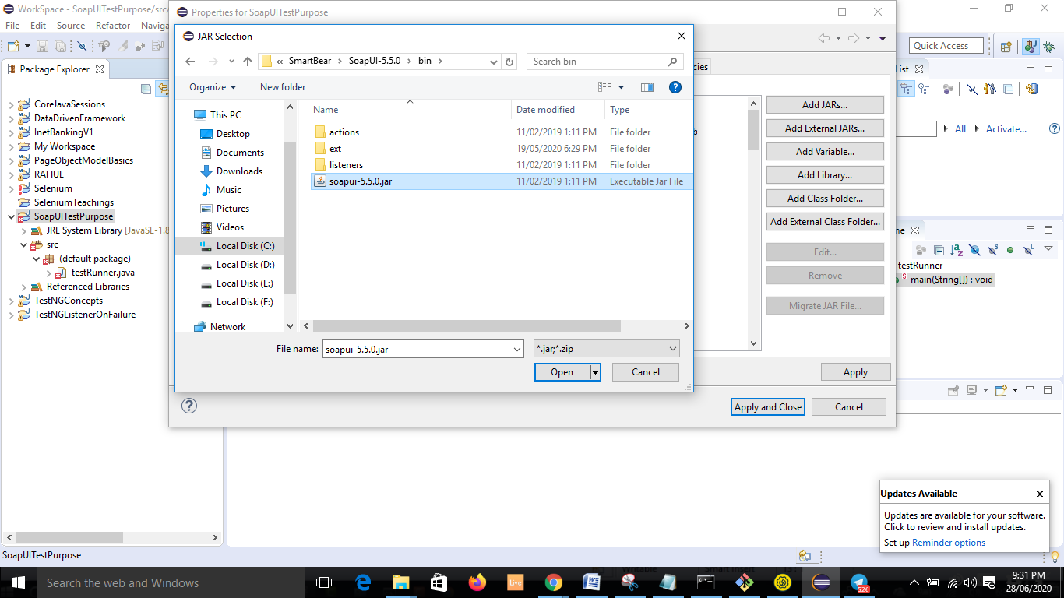

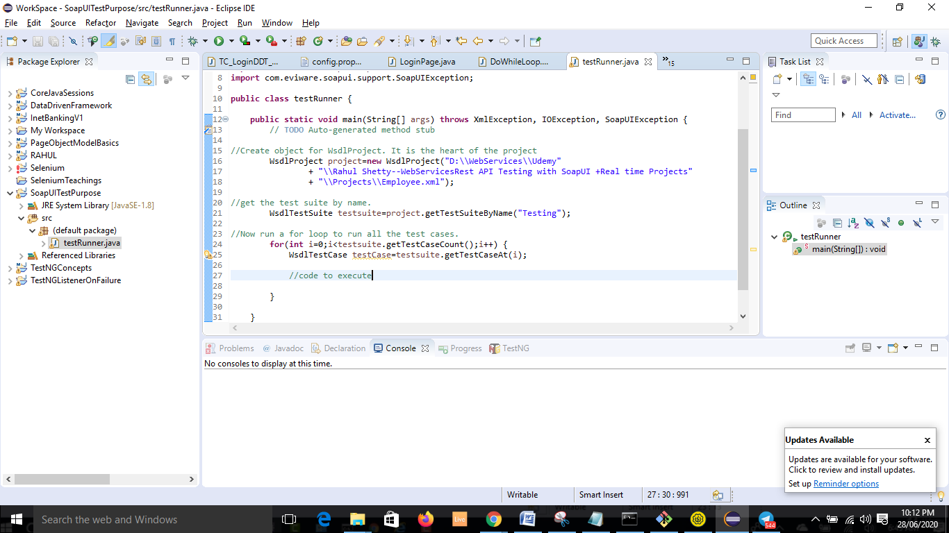

//Create object for WsdlProject. It is the heart of the project

WsdlProject project=**new** WsdlProject("D:\\WebServices\\Udemy"

+ "\\Rahul Shetty--WebServicesRest API Testing with SoapUI +Real time Projects"

+ "\\Projects\\Employee.xml");

//get the test suite by name.

WsdlTestSuite testsuite=project.getTestSuiteByName("Testing");

//Now run a for loop to run all the test cases.

**for**(**int** i=0;i<testsuite.getTestCaseCount();i++) {

WsdlTestCase testCase=testsuite.getTestCaseAt(i);

**57. TestNG Integration to the Java API Tests**

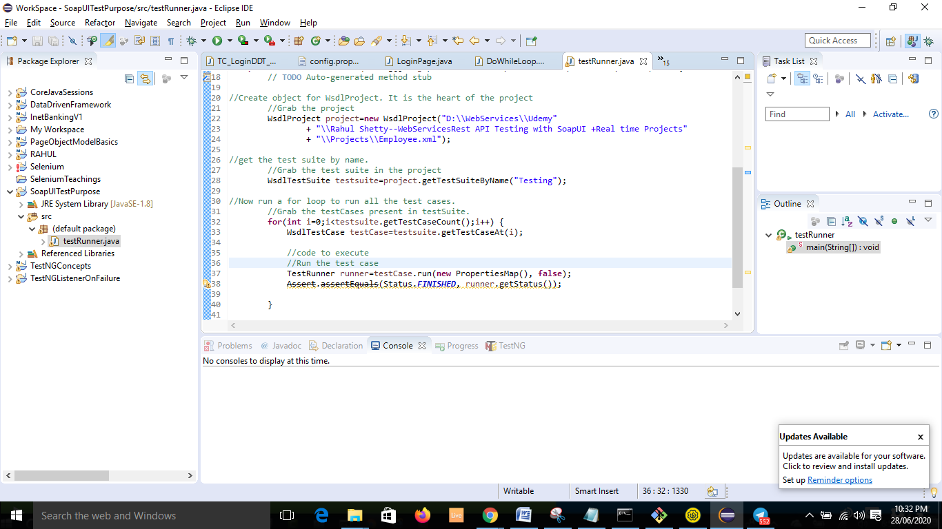

* We need to add one more jar.( jcommander). Import that jar as well.

